2024
PRICES
HELD
SINCE
2020!

Children go FREE with an adult & youth are just £49 for the whole weekend!

5-7 JULY 2024 YARNFIELD PARK, STAFFORDSHIRE

CMJ UK is a working title of The Vincent Society, a charitable incorporated organisation, England & Wales Registered Charity Number 1153457

REV. AARON EIME
THE SPEAKER

Deacon, Christ Church, Jerusalem
The Rev. Aaron Eime is a deacon at Christ Church Jerusalem and a teacher for CMJ Israel. Aaron studied in the master’s program at Hebrew University with a focus on early
Jewish and Christian interpretation of the Bible. He also studied psychology and sociology at Queensland University in Australia. Aaron is a
dedicated Bible teacher exploring the Hebraic roots of the Christian faith. He reads Aramaic and ancient Greek and is fluent in German and Hebrew. He has taught internationally, including in Europe, North America, Hong Kong, and China. He lives in Jerusalem with his wife and three children.
THINKING OF BRINGING YOUR HOME GROUP
OR STUDY GROUP? ASK ABOUT OUR GROUP DISCOUNT!
YOUTH LEADER GOES FREE WITH YOUTH!
THERE WILL BE VARIETY OF WORKSHOPS AVAILABLE!

Prices per person for the full weekend:
THE PRICES
A non-refundable £50 deposit secures your place.
Balance to be paid by 30th April 2024. Monthly payments can be arranged.

EARLY BIRD
Book by 31st January 2024 to take advantage of the early booking discount:
£255 (sole use of a room)
£215 per person (sharing a room)

FULL PRICE
£270 (sole use of a room)
£230 per person (sharing a room)
£95 Young Person (aged 19 - 25)
Youth ministry for ages 12 – 18 (at date of Conference): £49
(CMJ Youth Conference)
Church Groups discount available Youth Leader goes free with Youth
Children 11 and under (at date of Conference): FREE with a full-paying adult. Children’s ministry (CMJ Kids) led by Olly and Helen Goldenberg available for children aged 5 – 11.
Creche available for children aged 0 – 4 led by Lucy Pegg.

DAY VISITORS
We give priority to our residential bookings so day visitor bookings will not be available until the beginning of March 2024. A waiting list will be held:
email conference@cmj.org.uk

DAY | COST | DINNER/LUNCH
Friday | £35 | Includes Dinner
Saturday | £40 | Includes Lunch & Dinner
Sunday | £35 | Includes Lunch

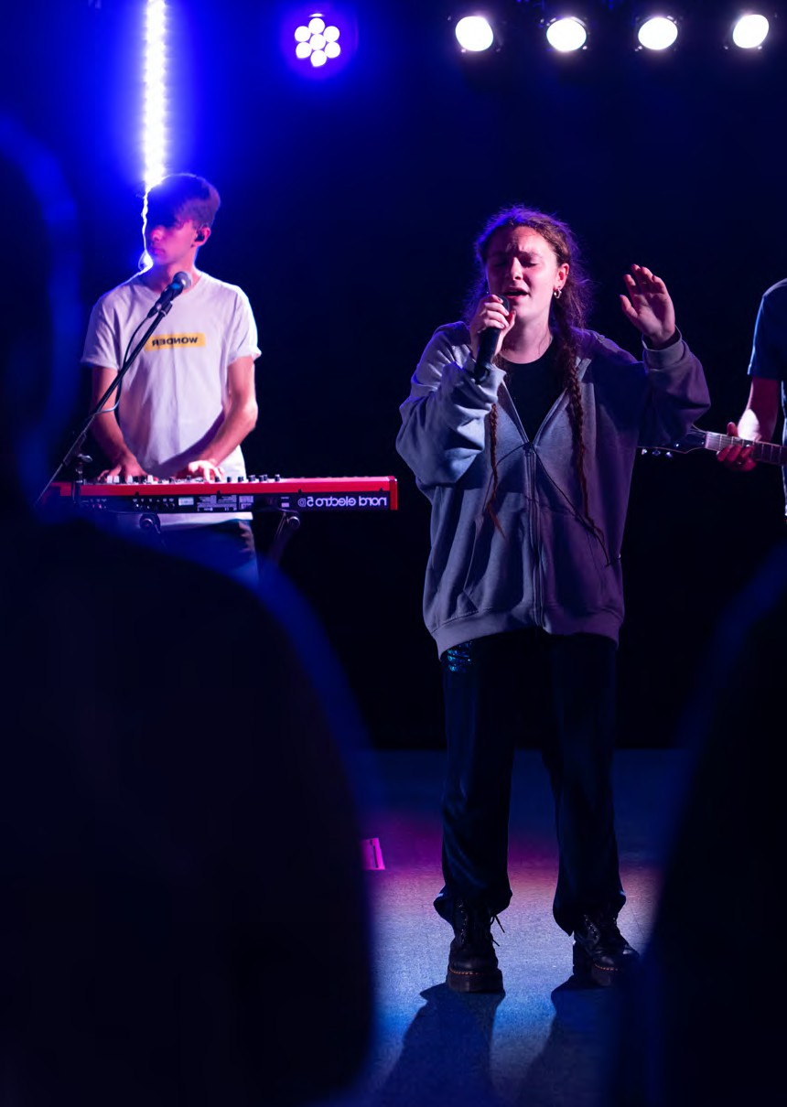
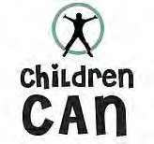
YOUTH & CHILDREN

YOUTH CONFERENCE

CHILDREN’S ACTIVITIES

BABY & TODDLER CRECHE

2024

CMJ UK Conference Booking Form 20 4

Please use a separate form for each person requiring a separate room.
23

PLEASE ANSWER ALL QUESTIONS
Name:
Address: Postcode:
Telephone: Mobile: e-mail:

Are you happy for us to share your name with other attendees, if requested? YES ☐ NO ☐ Would you like to be on our mailing list Yes ☐ No ☐ Already on ☐
We strive to keep your information secure and fulfil our obligations under the General Data Protection Regulation 2018. We keep membership records on our database to process donations, reclaim gift aid and send you relevant ministry updates. For full details email office@cmj.org.uk.

First Name (Preferred name for Badge if  different) | Surname | Age  (at date of Conference) | Room Type required |  |  |  |  | Disability / mobility Limitations? | Food allergies? | First time attending?
 |  |  | Single use (Ensuite) | Double (Ensuite) | Twin (Ensuite) | Family (Ensuite) Max 3 per  room | Cot required?
 |  |  |  |  |  |  |  | Yes / No | Yes / No | Yes / No
 |  |  |  |  |  |  |  | Yes / No | Yes / No | Yes / No
 |  |  |  |  |  |  |  | Yes / No | Yes / No | Yes / No

Please give more information about disabilities / mobility limitations noted above:
Name | Disability / mobility limitations we need to be aware of
Please give more information about food allergies / sensitivities noted above:
Name | Food allergies / sensitivities we need to be aware of

Please turn over

Booking terms and conditions:
Early Bird rate of £215 per person sharing a room and £255 per person sole use of room, if booking made by 31st January 2024. Thereafter the price increases to £230 per person sharing a room and £270 per person sole use of room. Children 11 and under are free. Young Person rate (aged between 19 and 25) is just £95 for the whole weekend. Youth Conference for 12-18’s only £49.
2023
Deposits: A non-refundable deposit of £50 per person is required at the time of your booking, excluding Youth Conference. The balance of your payment is due by 30th April 2024. Late bookings: If you book after 30th April 2024 you will be required to pay the full balance for each person at the time of booking.
2023
2023
Cancellation Policy: The majority of the cost of a residential event is the accommodation charge which we have to commit to the Conference Centre well in advance of the event. We are therefore, unable to give refunds after 1st May 2024 .
2023

PAYMENT INFORMATION
Full cost for those on this form (number of people x total amount payable each): £
Donation to the Bursary Fund: £ This is to help those who would be unable to attend the Conference.
Donation to CMJ UK £

Total cost £
Less Deposit to be paid (£50 per person x number of people on this form): £
2023

Balance owing to be paid by 30th April 2024 £

TOTAL AMOUNT PAYABLE WITH THIS FORM: (Deposits and donations) £ Please make cheques payable to ‘CMJ UK’.
Card payment: Card Type: Mastercard ☐ Visa ☐ Debit Card ☐ Credit card ☐ Card Holder (name as on card)
Card No: (16 figures) Expiry Date Security No.
_ _ _ _ / _ _ _ _ / _ _ _ _ /_ _ _ _ _ _ / _ _ _ _ _
- Please click here if you would like details of our monthly pre-pay scheme.
- Please click here if you would like to receive help from the Bursary Fund. Please note: Decisions concerning the Bursary Fund will be made by the CMJ DCEO.

Please check that you have completed all the required information before returning the form with payment to the following address:
CMJ UK, Eagle Lodge, Hexgreave Hall Business Park, Farnsfield, Nottinghamshire, NG22 8LS. For further information, please call 01623 883960 or e-mail
conference@cmj.org.uk

ADMIN USE ONLY
Date processed:
Entered onto Subscriber: Entered onto booking system:

Amount received:
Date acknowledgement letter sent:

Form scanned to Subscriber:

Payment type: CHQ / CASH / SQ/PayPal / BACS Initials: Monthly booking numbers updated:

Accom. Booked:
CC / BACS INITIALS:

Eagle Lodge, Hexgreave Park, Farnsfield, Notts, NG22 8LS, England.
CMJ UK is a working title of The Vincent Society, a charitable incorporated organisation, England & Wales Registered Charity Number 1153457
Tel: 01623 883960 Email: office@cmj.org.uk Web: www.cmj.org.uk
CMJ UK is a working title of The Vincent Society, a charitable incorporated organisation, England & Wales Registered Charity Number 1153457
www.facebook.com/CMJUK Instagram @CMJ1809 @CMJ1809
www.linkedin.com/company/cmjuk www.youtube.com/c/CMJUK @cmj1809

